**VISVESVARAYA TECHNOLOGICAL UNIVERSITY**

**“JnanaSangama”, Belgaum -590014, Karnataka.**



**PROJECT WORK-1 REPORT**

**On**

**TRAVELIX (RESORT BOOKING WEBSITE)**

***Submitted by***

**ISHITA RAY(1BM20CS061)**

**KARAN YADAV(1BM20CS069)**

**KEERTHANA N P(1BM20CS071)**

***Under the Guidance of***

**Dr. MANJUNATH D R**

**Assistant Professor, BMSCE**

***In Partial Fulfillment For The Award Of The Degree Of***

**BACHELOR OF ENGINEERING**

***in***

**COMPUTER SCIENCE AND ENGINEERING**



**B.M.S. COLLEGE OF ENGINEERING**

**(Autonomous Institution under VTU)**

**BENGALURU-560019**

**Oct-2021 to May-2022**

**B. M. S. College of Engineering,**

**Bull Temple Road, Bangalore 560019**

(Affiliated To Visvesvaraya Technological University, Belgaum)

**Department of Computer Science and Engineering**



**CERTIFICATE**

This is to certify that the project work entitled “**TRAVELIX (RESORT BOOKING WEBSITE)**” carried out by **ISHITA RAY(1BM20CS061), KARAN YADAV(1BM20CS069) , KEERTHANA N P(1BM20CS071)** who are bonafide students of **B. M. S. College of Engineering.** It is in partial fulfillment for the award of **Bachelor of Engineering in Computer Science and Engineering** of the Visveswaraiah Technological University, Belgaum during the year 2021-2022. The project report has been approved as it satisfies the academic requirements in respect of **Project Work-1 (19CS3PWPW1)** work prescribed for the said degree.

Signature of the Guide                 Signature of the HOD

Dr. Manjunath D R Dr. Jyothi S Nayak

Assistant Professor Assistant Professor

BMSCE, Bengaluru Head of Dept. of CSE

BMSCE, Bengaluru

External Viva

Name of the Examiner                                                                                       Signature with date

1._____________________________ ________________________

2. _____________________________ _________________________

**B.M.S. COLLEGE OF ENGINEERING**

**DEPARTMENT OF COMPUTER SCIENCE AND ENGINEERING**



***DECALARATION***

We **ISHITA RAY(1BM20CS061), KEERTHANA N P(1BM20CS071) and KARAN YADAV(1BM20CS069)** students of 3rd Semester, B.E, Department of Computer Science and Engineering, B. M. S. College of Engineering, Bangalore, here by declare that, this Project Work-1entitled "Travelix (Resort Booking Website)" has been carried out by us under the guidance of Dr. Manjunath D R , Assistant Professor, Department of CSE, B. M. S. College of Engineering, Bangalore during the academic semester Oct-2021-May-2022.

We also declare that to the best of our knowledge and belief, the development reported here is not from part of any other report by any other students.

Signature

**ISHITA RAY(1BM20CS061)**

**KARAN YADAV(1BM20CS069)**

**KEERTHANA N P(1BM20CS071)**

**TABLE OF CONTENTS**

|  |  |
| --- | --- |
| TITLE | PAGE NUMBER |
| Introduction | 5 |
| About the Website | 5 |
| About the Project | 5 |
| Functionalities | 6 |
| Home page for user | 8 |
| Project layout and Source Code | 14 |

**1. INTRODUCTION**

Website development for “Resort Booking Website”

**1.1 ABOUT THE WEBSITE**

This Website system is for everybody who wishes to travel.

Our website allows users to book resorts easily to have a comfortable stay while travelling to different places.

**1.2. ABOUT THE PROJECT**

Travelix is a resort booking portal.

This website allows the user to pick any travel destination among Bangalore, Delhi and Mumbai and allows the user to pick a resort of their choice.

It provides the user with a wide range of rooms to pick from, according to their needs.

It also allows the user to book a ride to the resort in which they are staying.

**1.3 FUNCTIONALITIES**

* Select a city:

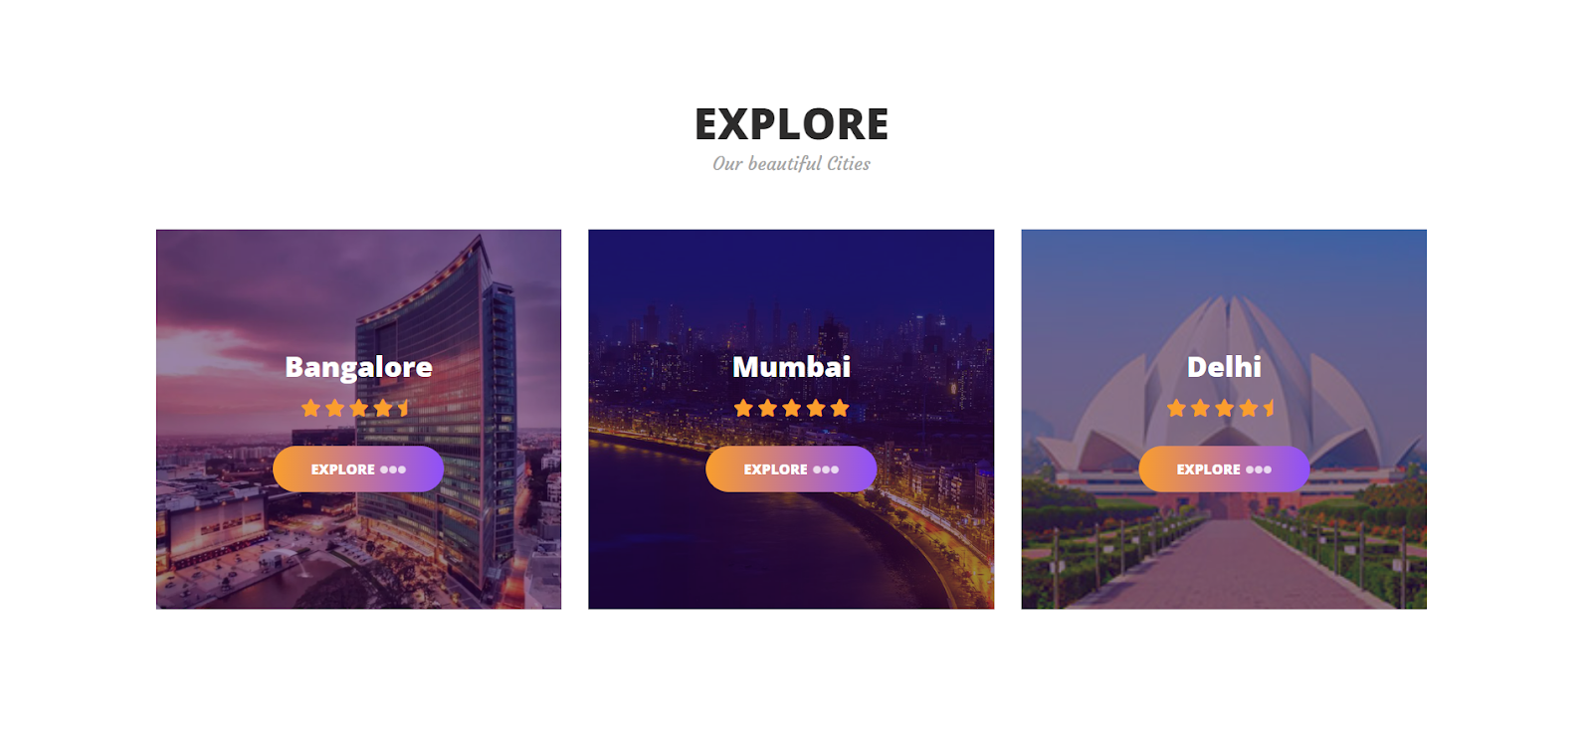

The user has to first select a place of his choice. The user will be provided with an option to select from the following cities: Mumbai, Delhi, Bangalore. Once selected, the user have to select a resort of their choice. Upon doing so they’ll be redirected to the Booking page. The ratings is also provided.

* Select a resort:

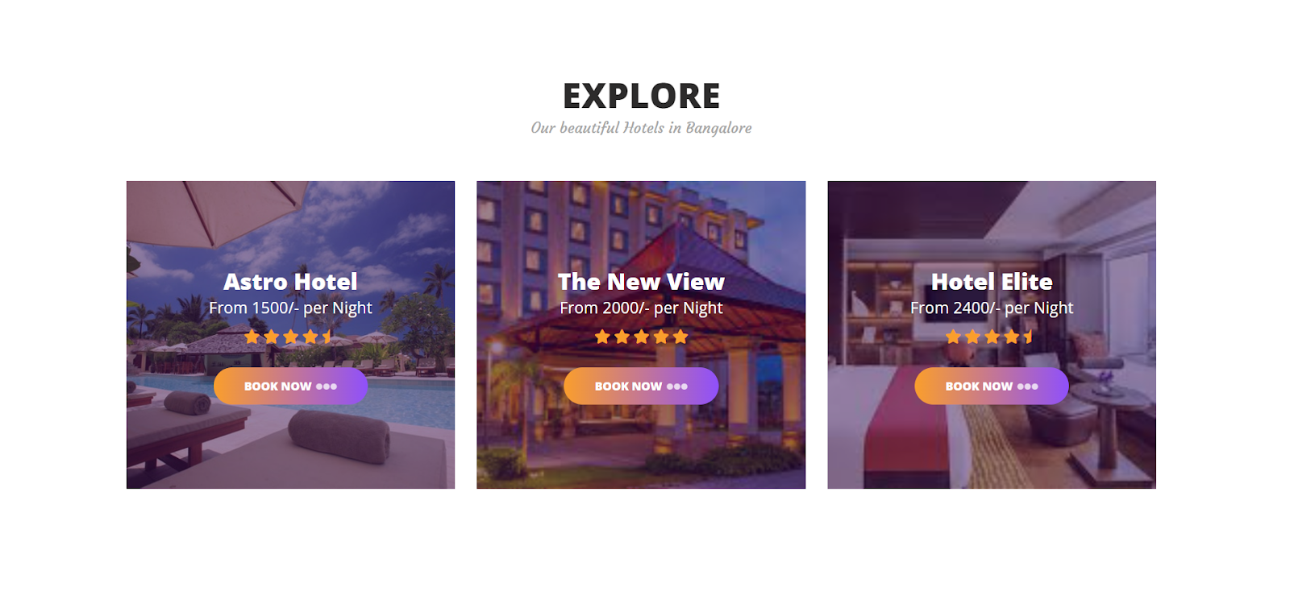

The user after selecting a particular city, will be redirected to some of the resorts in that city. The user can select a particular resort of their choice, and then click on the book now button.

* Booking page:

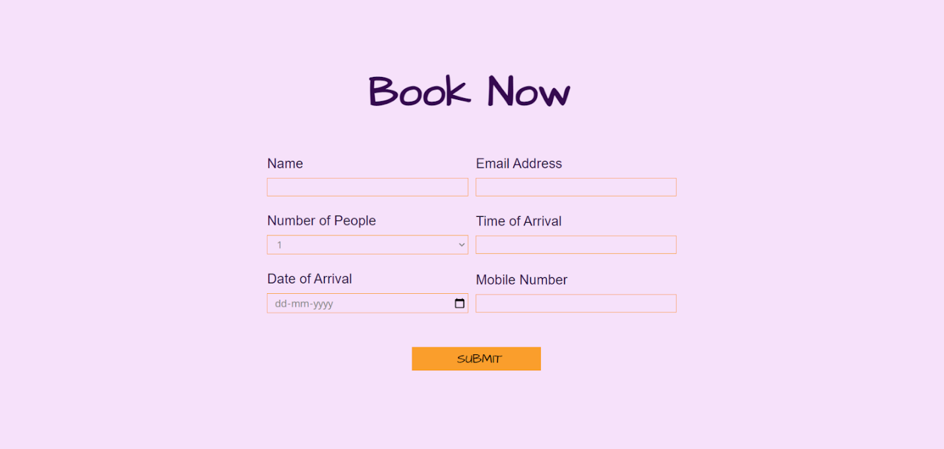

The user will have to provide the name, email address, number of people, Time of arrival, Date of arrival, Mobile number details for booking, And then he has to click on the submit button to book a particular resort.

* 1. **HOME PAGE FOR USER**

1. Home Page
2. About Us
3. Book a Ride
4. Contact Us
5. Home page:

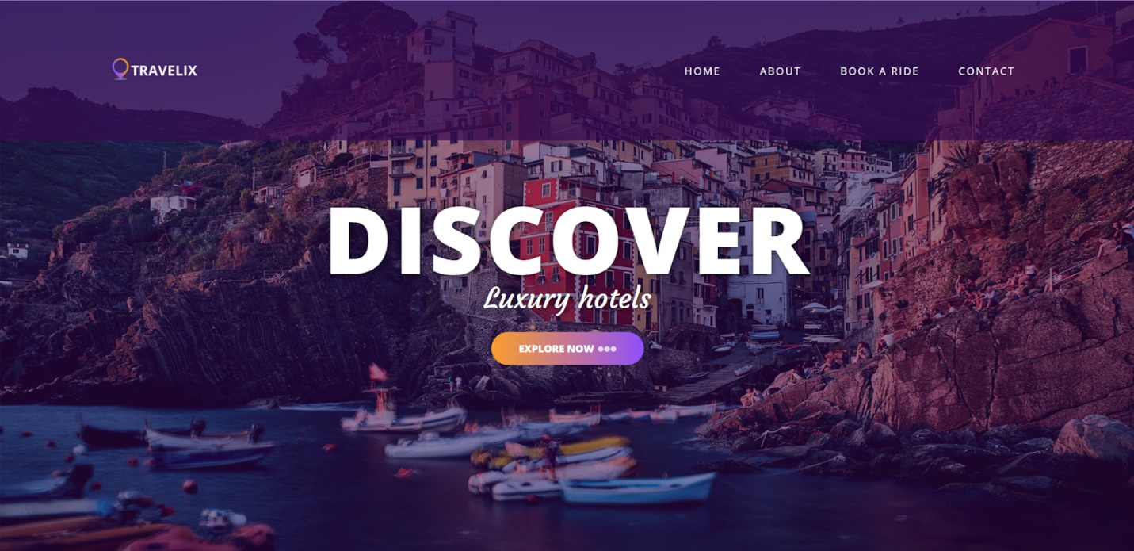

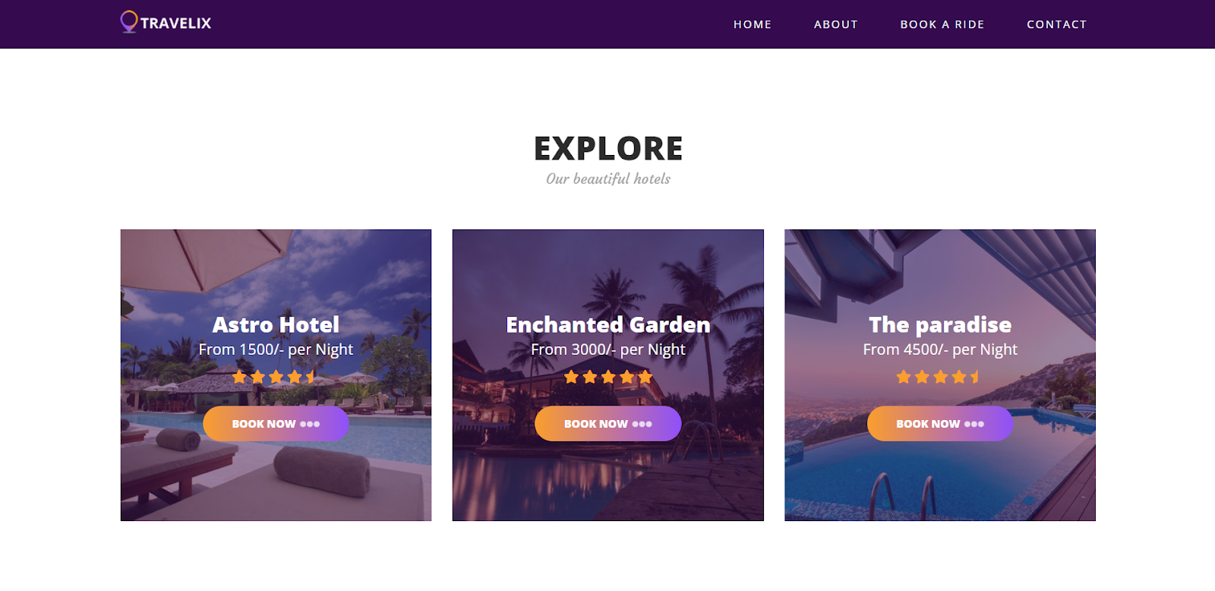

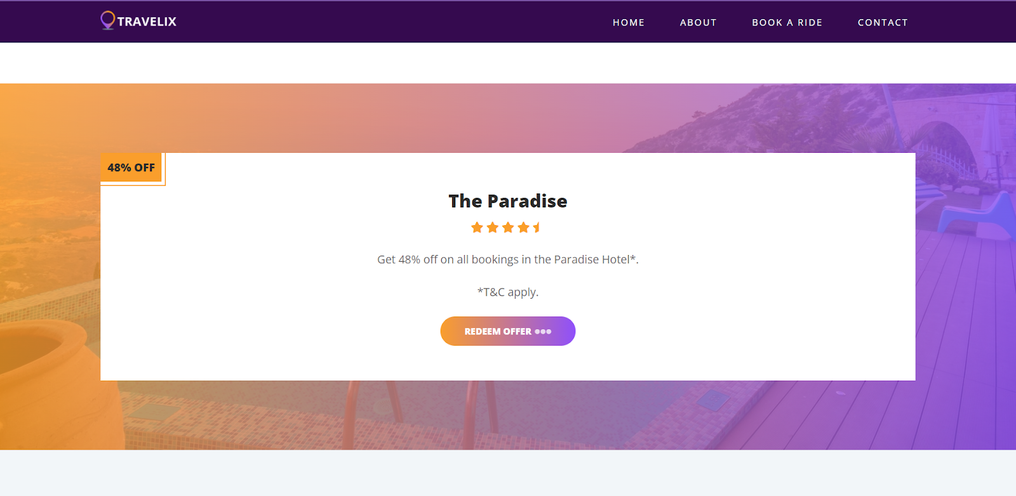

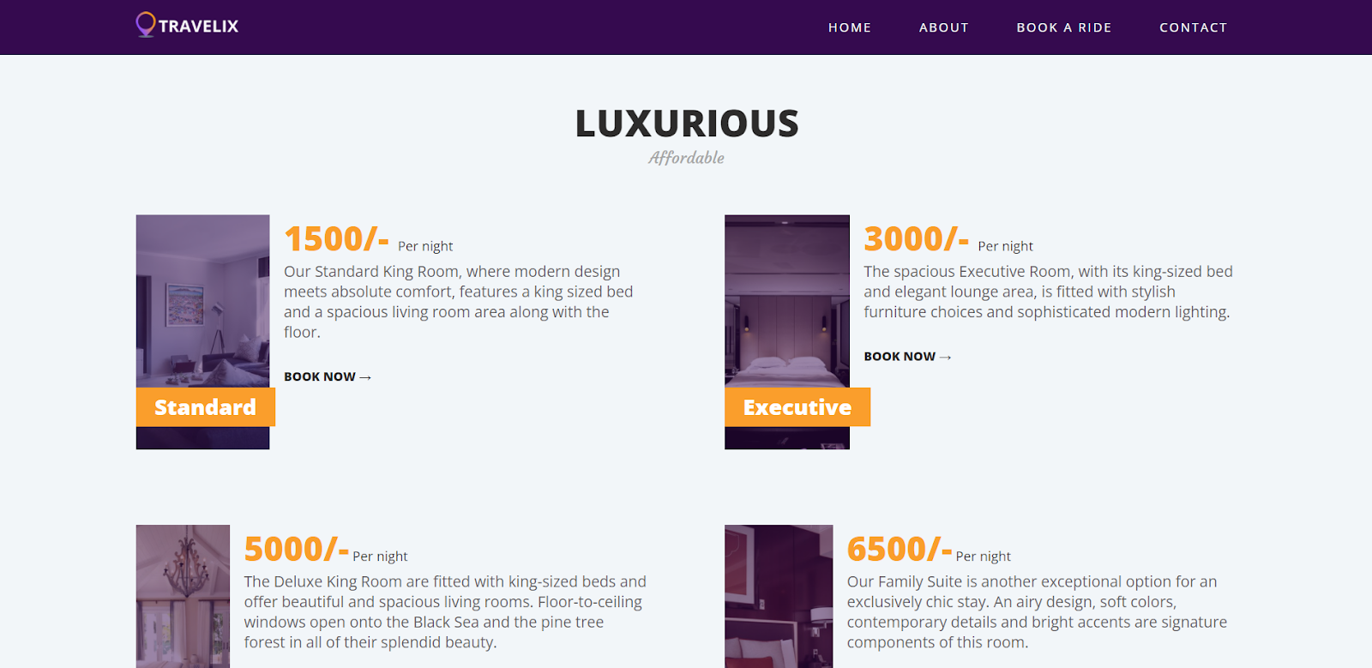

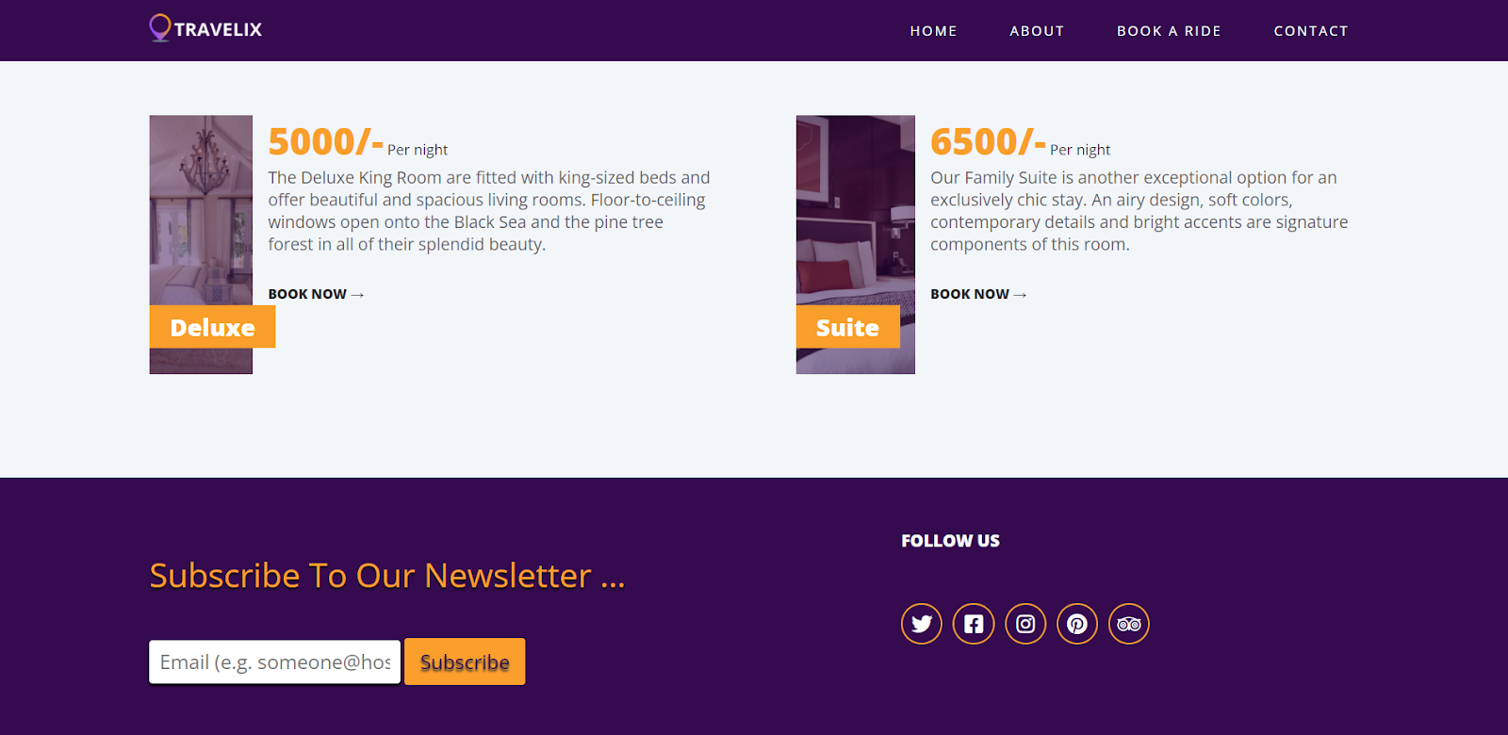

The home page is designed for the user to explore new resorts in a particular city. They can even select a room of their choice. They will be provided with offers also.

1. About us:

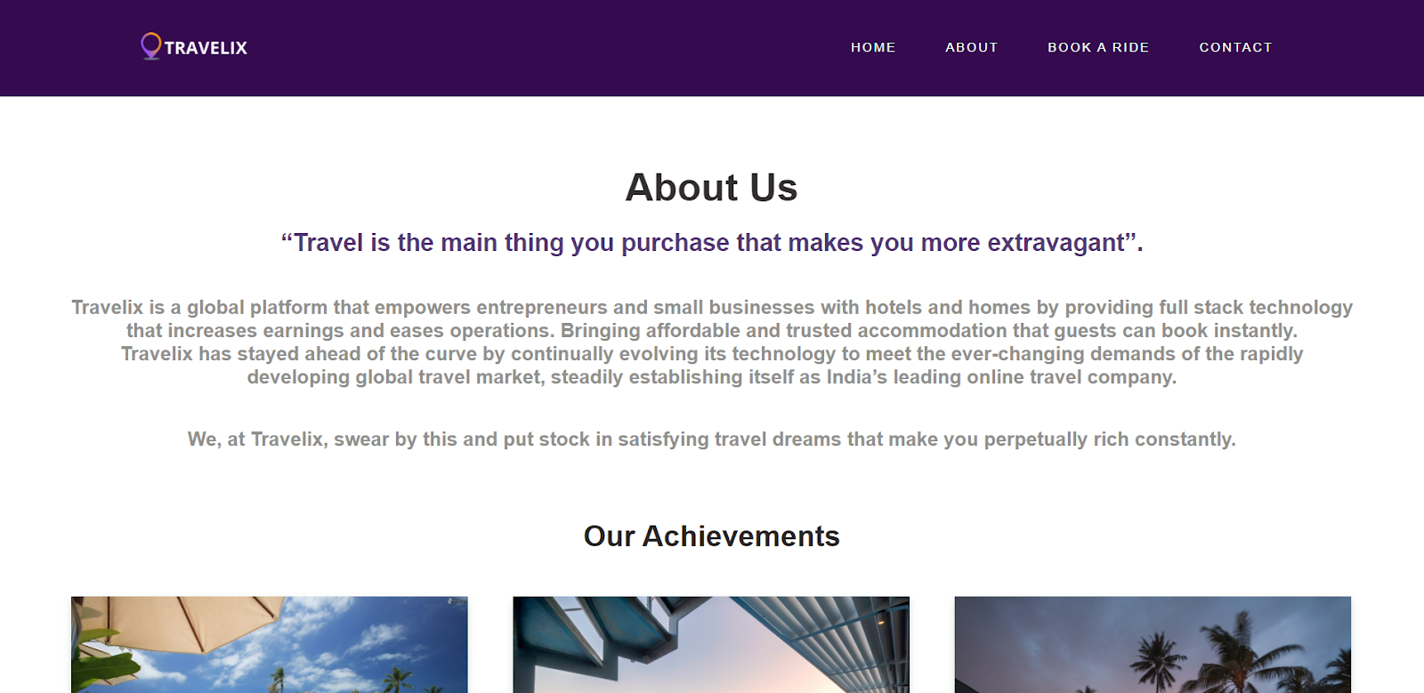

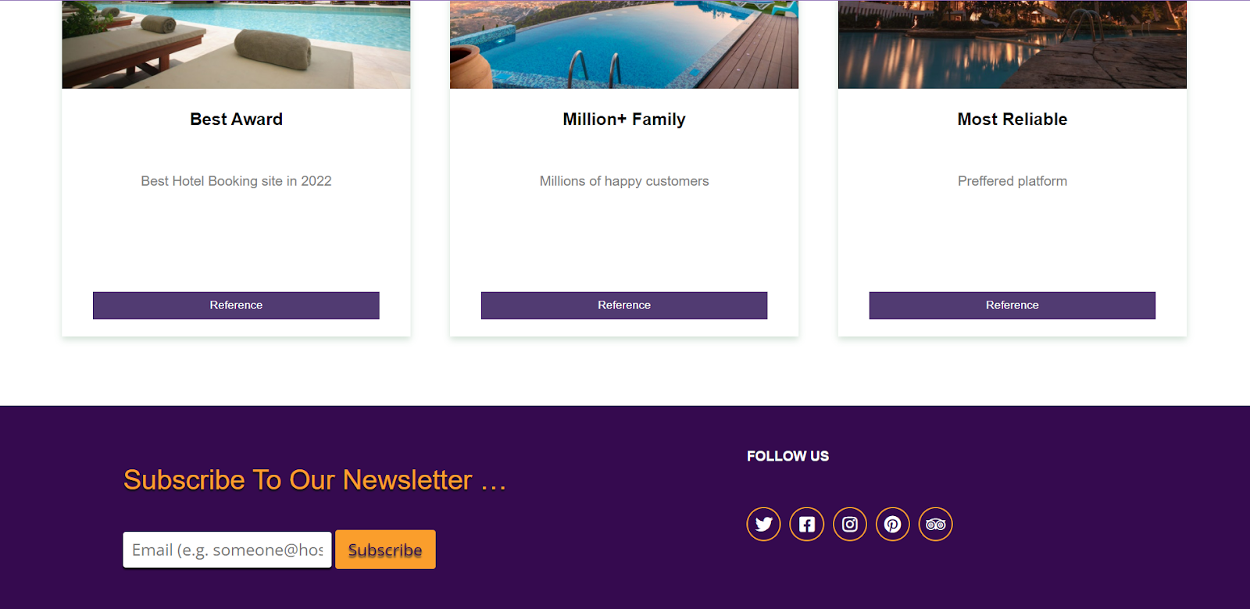

This page contains the description of our website. It also contains the achievements of our website and by clicking on the reference you can read more about the particular achievement.

1. Book a Ride:

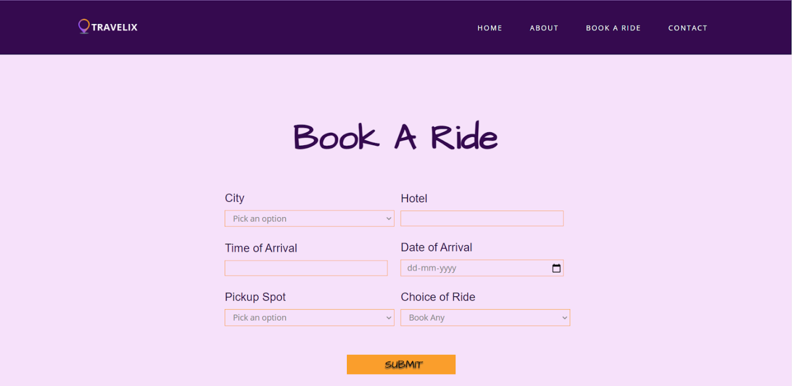

This page is designed so that the user can book a ride from wherever he is. He has to select a city, Hotel, Time of arrival, Date of arrival, pickup spot and choice of ride. And then click on the submit button for confirmation.

1. Contact Us:

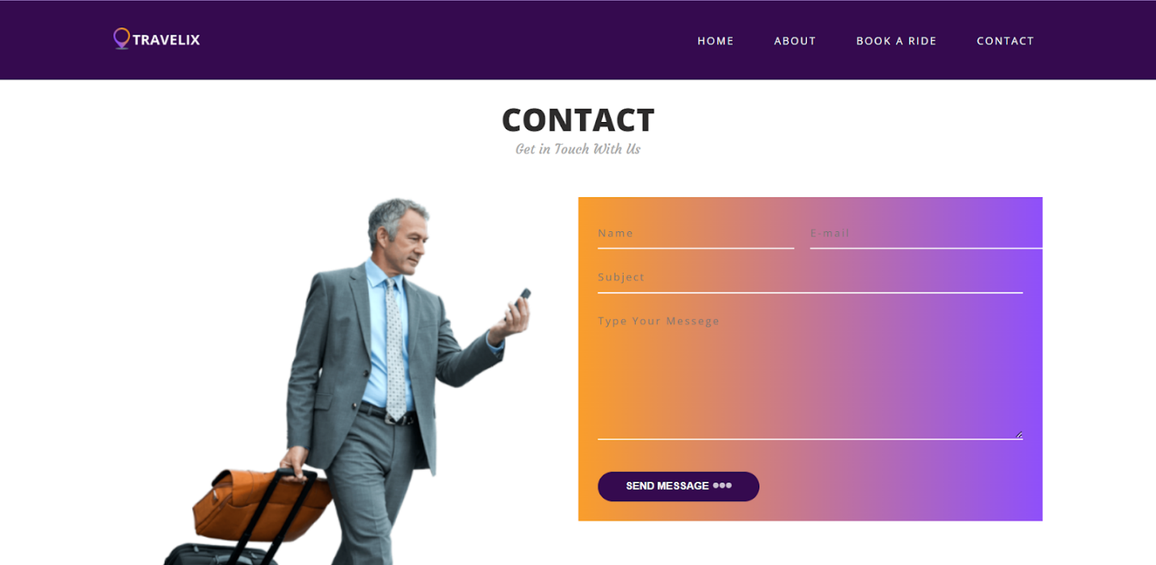

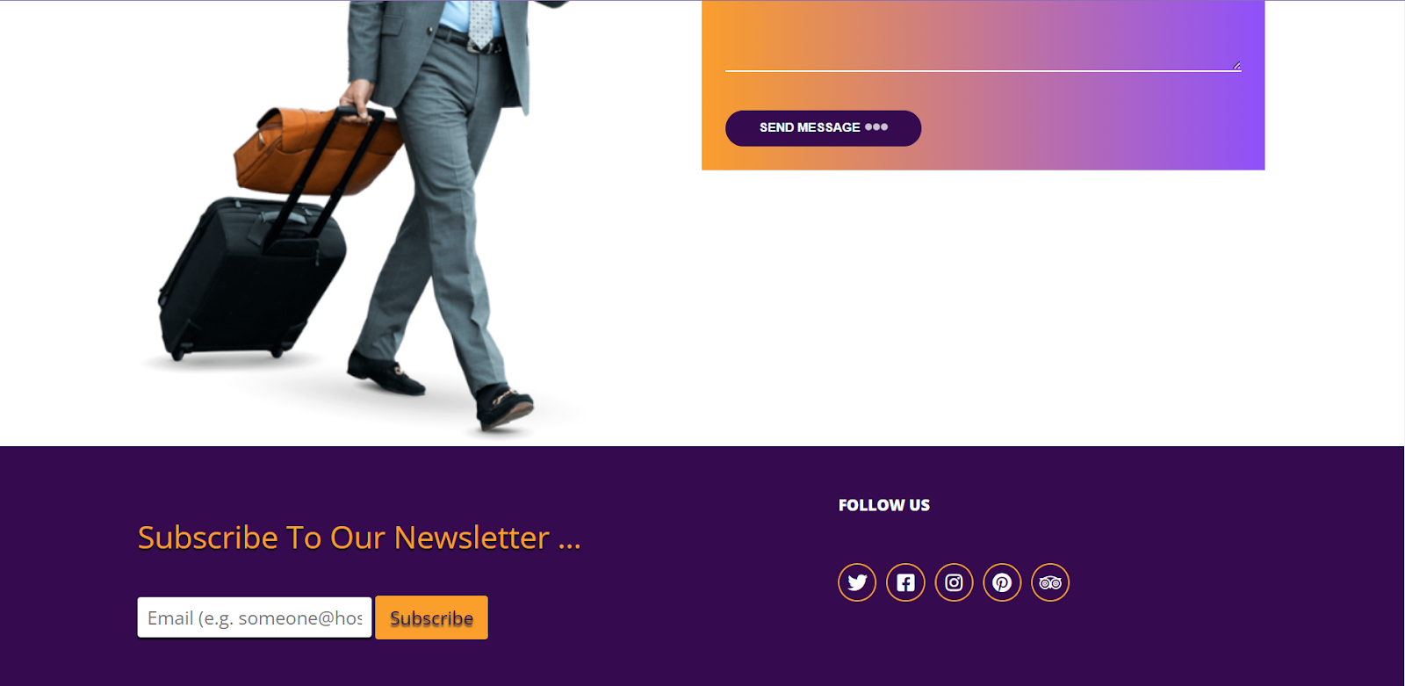

The Contact-Us page is designed with the intent to provide the user an option to contact us regarding issues, doubts about submission or other queries/questions. Field Names ending with * are compulsory fields.

**1.5 PROJECT LAYOUT**

**SOURCE CODE LINK:**

The following link directs you to the GitHub repository which contain the source code to all of the above-mentioned webpages.

<https://github.com/KeerthanaNP15/Project>

**LAYOUT:**

Newsletter

Resort

Home Page

Book

City

Rooms

Offers

Explore

Contact

Book a ride

About Us

Home